**Cantilever beam example**

**Material Properties:**

Young’s Modulus E: 2.0340e11

Shear Modulus G: 7.8835e10

Density: 7850

**Geometry:**

Uniform square cross section: t = 0.02

Length: l = 25

**FEA Model:**

Number of Elements: 10

Boundary condition: clamped at left end

Loading condition: Tip load at right end

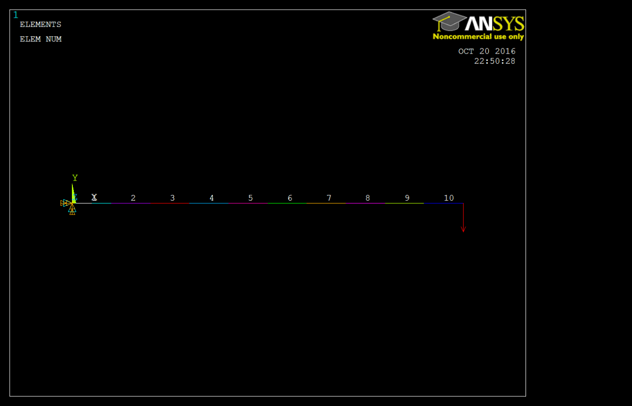

Fig. 1. FEA model with element number

**FEA Results:**

Tip deflection: -1.917

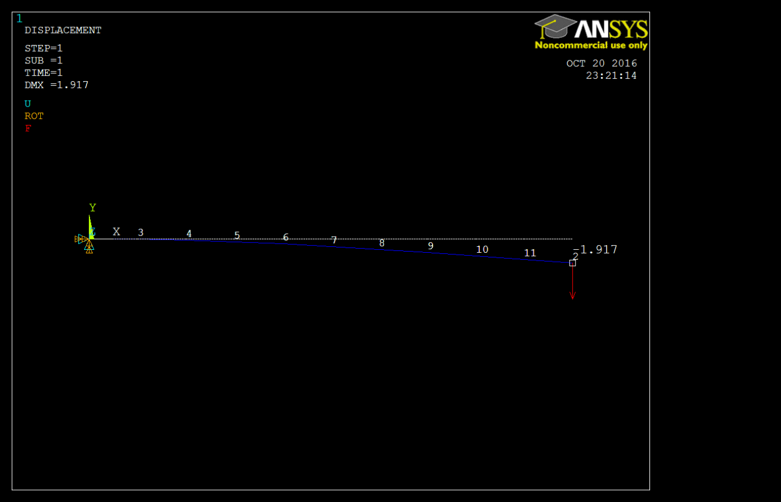

Fig. 2. Deformed shape with node number and tip deflection

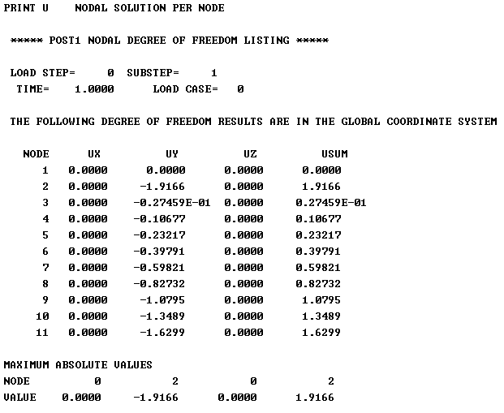

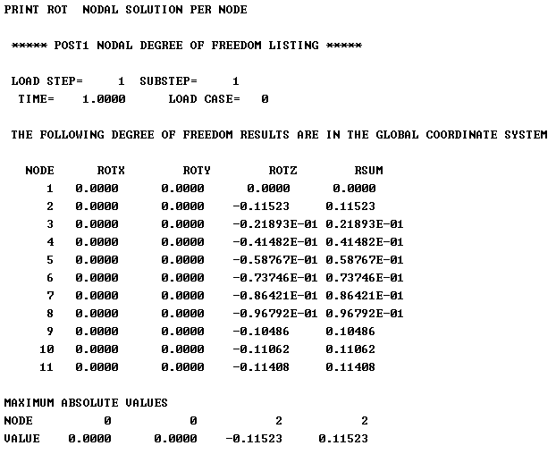

Fig. 3. Nodal DOF

**Convergence Study**

Apply the same problem on a FEA mode with 11 elements, same tip deflection is obtained. It is convergent. 10 elements are used for this mode.

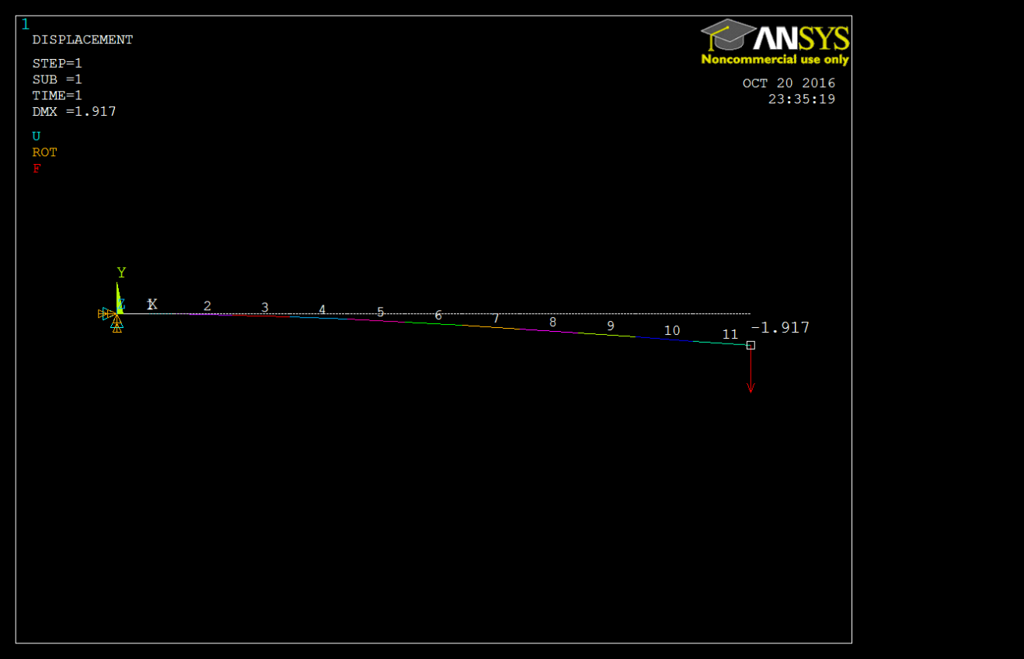

Fig. 4. Deformed shape for 11 elements with tip deflection